TASK 37 : INSTALL A PLUGIN IN JENKINS (BONUS TASK) • Activity: • Install a “NodeJS” plugin in Jenkins. • Steps: • Go to Manage Jenkins -> Manage Plugins -> Available • Select NodeJS and install without restart • Go to Manage Jenkins -> Global Tool configuration • Global npm packages to install give as -> bower@~1.8.0 grunt-cli@~1.2.0 • Definition of Done: • NodeJS could be viewed under the Installed tab

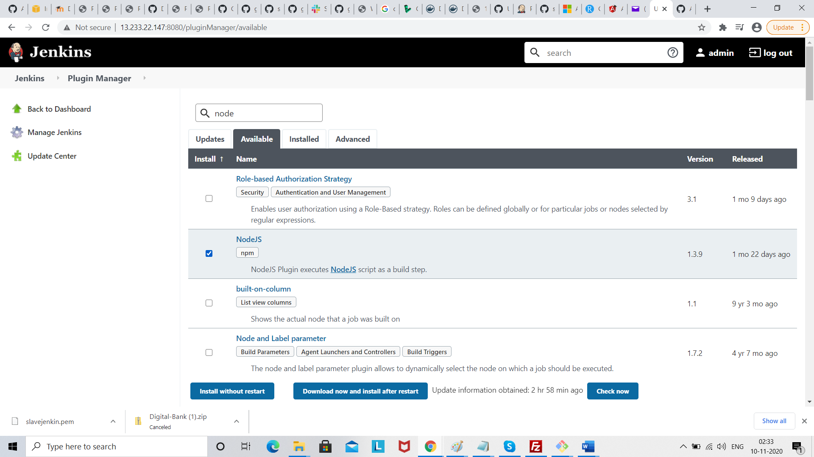

Click install without restart

